AP WORLD HISTORY ASSIGNMENT

SUMMER 2016

AP WORLD HISTORY SUMMER ASSIGNMENT

Welcome to Advanced Placement World History. During this course we will explore the history of humanity, a journey that will take us across time and space from the dawn of humans through the 21st century. The goals of the course are to become aware of how humans have, and continue to, transform the world and to become better students of history. We will work toward these goals through the practice of analytical thinking, critical writing and Socratic discussion.

The summer assignment is designed to lay a foundation for the course. It has three parts; the reading provides an excellent overview of the scope of the course. The map assignment lays ground work for our starting point and the flashcards give you a head start on your responsibilities for the first unit.

The Assignment

PART ONE: Summer Reading A History of the World in Six Glasses by Tom Standage

. 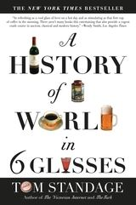

Standage, Tom. A History of the World in 6 Glasses. 2006.
ISBN-13: 978-0802715524 .

In his this book, Tom Standage takes the reader on a journey through history from c. 10,000 BCE to the present by following the development of six influential beverages: beer, wine, spirits, coffee, tea, & Coca Cola*. Each of these beverages has played a role in driving trade and interaction between people and civilizations. Your assignment is to read and take notes on the book.

Notes need to be hand written and are to include the main points and interesting facts from each chapter. You may infuse questions that come to you as well. You are free to decide the format your notes, just be sure that they are neatly written and well organized. Your notes will be collected on the first day of class.

Although we certainly encourage you to discuss the book with friends, it is imperative that your work is your own. If you have the same notes as another you will be in violation of the honor code.

*DISCLAIMER: The use of this book as a summer reading assignment in no way represents any endorsement of the consumption or misuse of these beverages. The book is simply meant to provide an interesting view of civilizations and trade, from which we can initiate our year-long discussion of world history.

PART TWO: The Map

Mapping Exercise
Neatly label the attached world maps with the land and water features listed below. Use the colors indicated in parentheses. Print neatly and make sure your maps are easy to read.

Map 1: AP World Regions
To find this map Visit https://apstudent.collegeboard.org/apcourse/ap-world-history, go the link AP World History Course and Exam Description PDF and scroll to page 42. Using the world map provided in this packet, draw and label the AP Regions based on the “closer view.” Use striping to indicate regions that overlap.

Map 2: Bodies of Water and Rivers
- Oceans, Seas, Bays, Lakes (draw in blue ink)
  - Atlantic Ocean
  - Pacific Ocean
  - Indian Ocean
  - Arctic Ocean
  - North Sea
  - Baltic Sea
  - English Channel
  - Norwegian Sea
  - Barents Sea
  - Mediterranean Sea
  - Adriatic Sea
  - Aegean Sea
- Rivers (draw in blue)
  - Nile River
  - Tigris River
  - Euphrates River
  - Amazon River
  - Mississippi River
  - Rio Grande
  - Indus River

Map 3: Mountains and Deserts
- Mountains ( brown)
  - Alaska Range
  - Rocky Mountains
  - Appalachian Mountains
  - Andes Mountains
  - Alps
- Deserts (yellow)
  - Gobi Desert
  - Kalahari Desert
  - Sahara Desert
  - Sierra Madre Desert

- Black Sea
- Caspian Sea
- Great Lakes
- Red Sea
- Persian Gulf
- Arabian Sea
- Bay of Bengal
- South China Sea
- East China Sea
- Yellow Sea
- Sea of Japan

- Yellow River (Huang He)
- Yangtze River
- Ganges River
- Irrawaddy River
- Mekong River
- Congo River
- Danube River

- Atlas Mountains
- Ural Mountains
- Hindu Kush
- Himalaya Mountains

- Mojave Desert
- Namib Desert
- Syrian Deserts

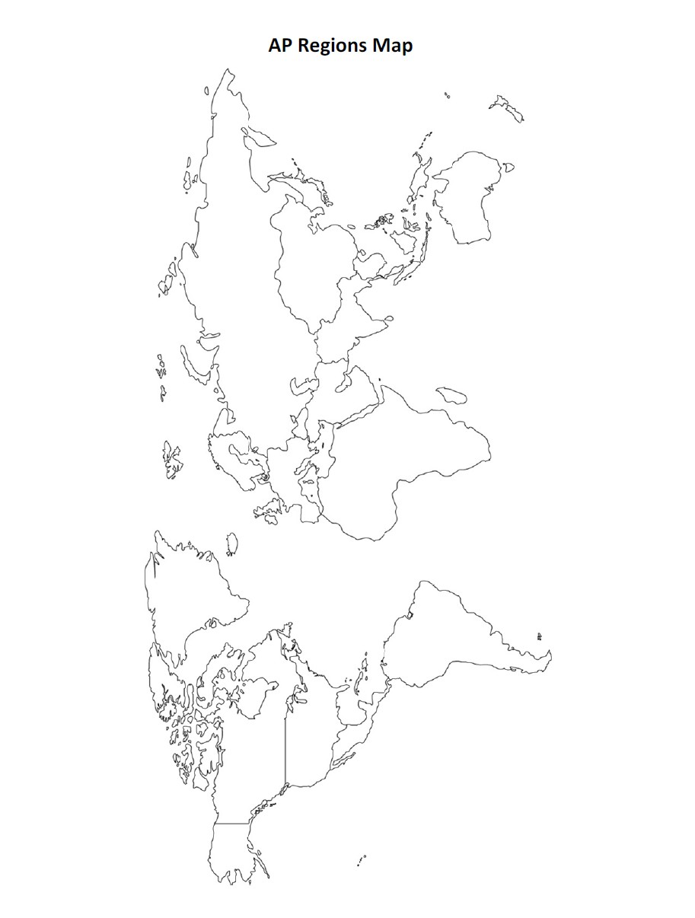
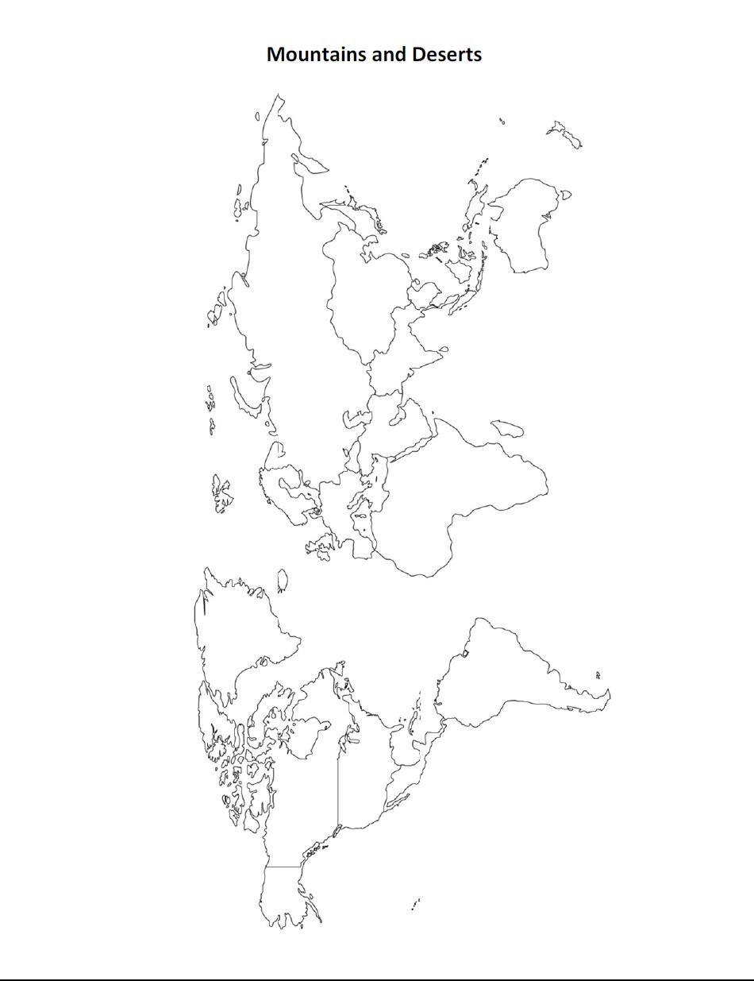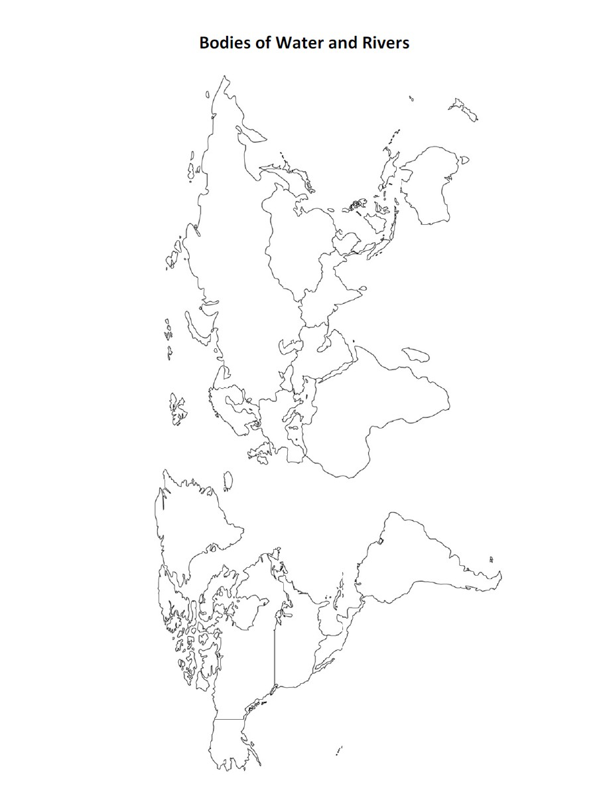

Part 3: Notecards Assignment

Directions: AP World History students should purchase the Barron's AP World History study book. Students will read pages 1 to 43 to get an overview of the exam & the study book. Students will make notecards on the following vocabulary found in the Barron's book on pages 57 to 75. Write the vocabulary on the front of the notecard and write a complete definition on the back. We will be building on this vocabulary throughout the school year and we will be making more notecards for each unit. SO please stock up on notecards, as well. The vocabulary is divided in groups of 10 because studies show that breaking information into smaller groups makes it easier to remember.
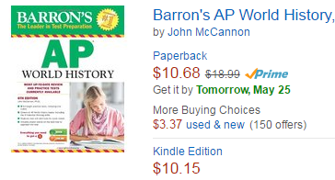
ISBN-13: 978-1438002729

P57-60  Prehistory  Oceania  Africa  Sahara  Asia  Europe  Eurasia  Afro-Eurasian  North & South America  Water transport | P61-64  Pastoralism  Agriculture  Domestication of animals  Social stratification  Cultural diffusion  Hierarchy  Patriarchalism  Polytheism  Bronze Age  Metallurgy | P68-69  Indus River Civilization  Mohenjo-Daro  Harappa  Mesopotamian-Indus trade  Huang-He River Civilization  Shang Dynasty  Silk  Pictograms  Iron weapons  Mandate of Heaven
Out of Africa Thesis  Peopling of the earth  Bering land bride  Stone Age  Paleolithic  Neolithic  Nomadic  Animism  Ancestor veneration  Shamans | p65-67  Mesopotamia  Sumerians  Babylonians  Assyrians  Akkadian conqueror Sargon  Cuneiform  Gilgamesh Epic  Hammurabi  Ziggurat  Hittites | P70-72  Olmecs  Human sacrifice  Quipu  Chavin  Nubia  Monotheistic  Homeric Epics  Phoenicians  Indo-European  Bantu
 | P67-68  Nile River Civilization  Old Kingdom  Middle Kingdom  New Kingdom  Egypt-Nubian trade  Pharaoh  Egyptian book of the Dead  Hieroglyphics  Papyrus  365 day calendar | P72-75  Theocracy  Oligarchy  Zoroastrianism  Vedism  Brahmins  Karma  Judaism  Abraham  Moses  Ahura Mazda

