Tang Art Analysis Activity Name: __________________ Mod: ____ Date: _____
KC: 3.2; HTS: 1A, 1B; TLO: CUL, SB; Region: EA
- Read the “Introduction” Only (4 pages) of “China’s Cosmopolitan Empire: Tang Dynasty” by Mark Edward Lewis
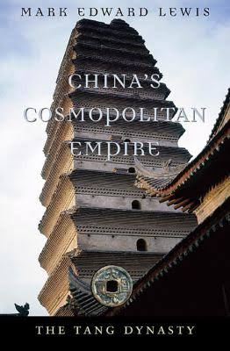
https://books.google.com/books?id=FJ4PrgBOVwgC&printsec=frontcover&dq=China%27s+Cosmopolitan+Empire:+The+Tang+Dynasty&hl=en&sa=X&ved=0ahUKEwiojLKSmeXPAhXkwFQKHQ-IAN0Q6AEIJDAB#v=onepage&q&f=false

- Go to either of the following two sites and choose 5 pieces of art to analyze -
  - University of Washington Tang Art Page with Explanations: http://depts.washington.edu/silkroad/exhibit/tang/tang.html
  - Metropolitan Museum of Art Tang Exhibit: http://www.metmuseum.org/toah/hd/tang/hd_tang.htm
- Choose 5 pieces of art to analyze.
1.
2.
3.
4.
5.

- Analyze those pieces for these things: What is the historical context of this piece of artwork?

- Analyze those pieces for these things: Does the artwork support or refute Lewis’ claim?

- Make a thesis statement that either supports or refutes Lewis’ claim based on what you found in the art pieces!

